Criterion C – Development

**Word Count:** 831

Contents

Program Structure 4

Packages 4

Object-Oriented Programming 5

Encapsulation 6

Aggregation 6

Method Overloading 7

Error Handling 8

Using Try/Catch 8

User Input Validation 9

Registration/Login 9

Company Addition 9

Use of Files 11

Authentication 11

User 12

Creating User File 12

Retrieving User’s Companies 12

Company 13

Structure 13

Retrieving Company Data 14

Retrieving Statistic Data 16

Functionality 18

Company Merging (ArrayList of Objects, For Each Loop & Comparator) 18

Company Valuation (ArrayList of Objects, For Each Loop, For Loop) 21

Data Extrapolation 21

Final Calculation 24

Statistic Graphing (ArrayList of Objects, For Each Loop) 24

Linked List of Company Objects 26

Interface 28

Libraries 31

References 35

# Program Structure

## Packages

The program is organized into packages for easier maintainability, the main packages being: “model”, “resources,” and “view.”

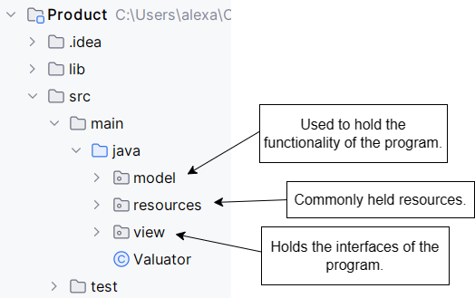

Screenshot 1 Program structure.

# Object-Oriented Programming

Object-Oriented Programming (OOP)[1] is a method of programming that takes problems, such as simulating real world entities such as, in my use cases, companies and users, and breaks them down into smaller tasks and representations using code[2]. I hate utilizing OOP in my program to model the relationship more easily between users and companies, and companies and their data.

Code 1 Object-Oriented Programming.

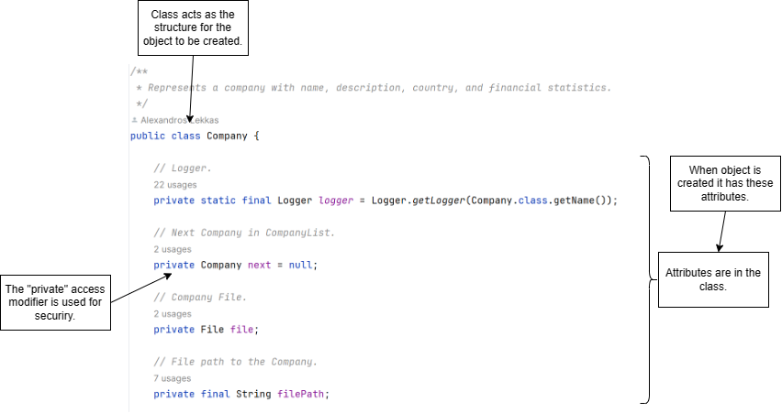

## Encapsulation

Encapsulation[3] refers to the building of data with the mechanisms that operate the data. This means advanced data security, meaning that we can define how different classes or users of the program are allowed to access certain pieces of data.

Code 2 Encapsulation.

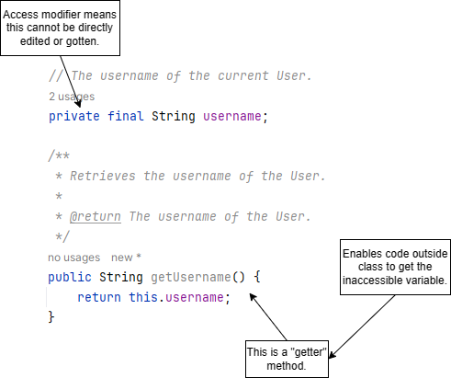

## Aggregation

To represent the complex relationships contained in my program, I used aggregation[4], where one class has a ‘has’ relationship with another. What this means is that one class contains an object of another class.

Code 3 Aggregation.

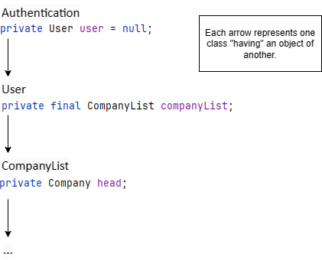

## Method Overloading

Method overloading[5] is a feature in Java is a feature allowing for a class to have more than one method with the same name but with different attributes. In my program, I used this for creating a Company object in different scenarios.

Code 4 Method overloading.

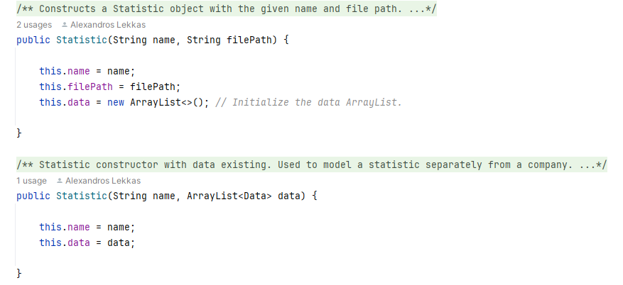

# Error Handling

## Using Try/Catch

Try/Catch is a convenient functionality of Java[6], where if there is an error during the running of the program, if the “catch” implementation is there, the program will not fail. Instead, we can create a way for the program to respond to the error (this is used to fulfill success criterion 3).

Code 5 Try/catch error handling.

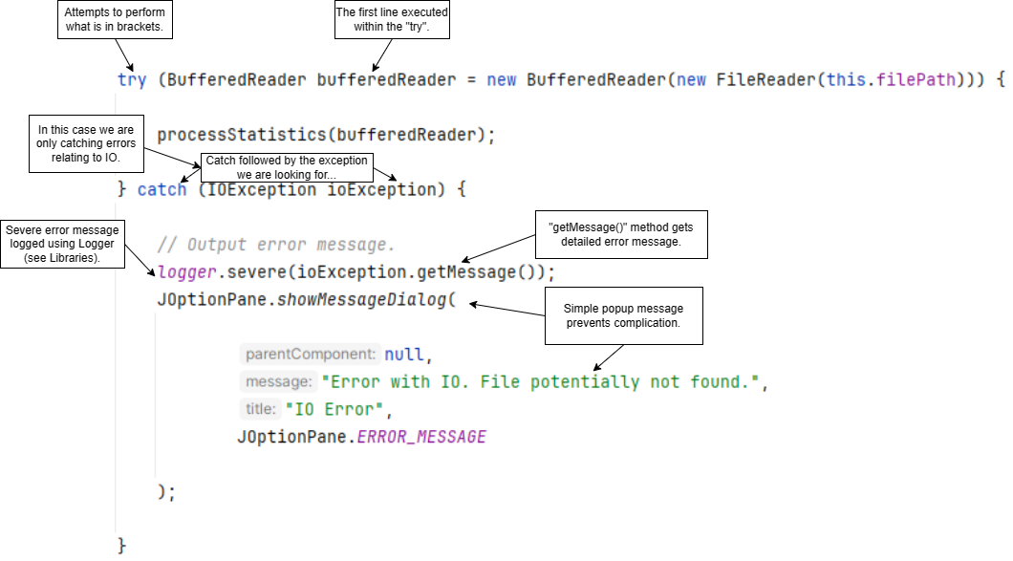

# User Input Validation

## Registration/Login

During login and registration, the user inputs their username and password, we validate if they are blank or equal to the placeholder text using if statements (this technique was used to satisfy success criterion 3).

Code 6 Registration/login input validation.

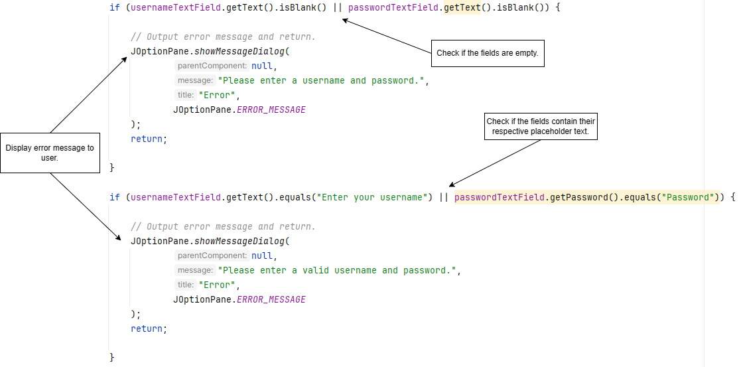

## Company Addition

When adding a Company from a file, the file selected by the user is checked to see if it is a CSV file[7] (this technique was used to satisfy success criterion 3).

Code 7 Company file checking.

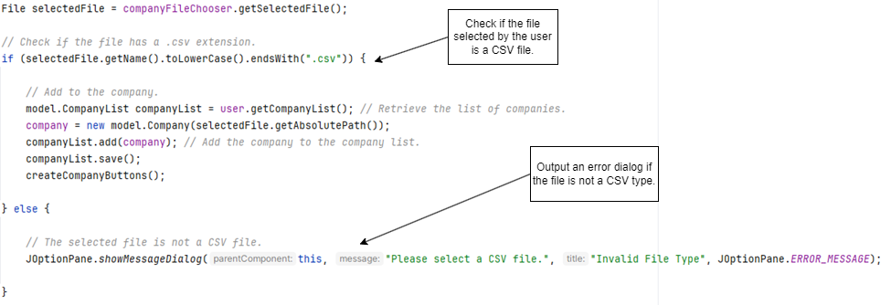

# Use of Files

## Authentication

For storing the data of authenticated users, I implemented a RandomAccessFile[8]. A random-access file is a file which “behaves like a large array of bytes stored in a file system.” I used this file for my user authentication system. I use the Random-Access File because it is easy to create it when the program is run, and it has improved efficiency in CRUD operations[9]. In this file, I store data in an expected structure of a string paired with another string to represent the username and password.

Code 8 RandomAccessFile.

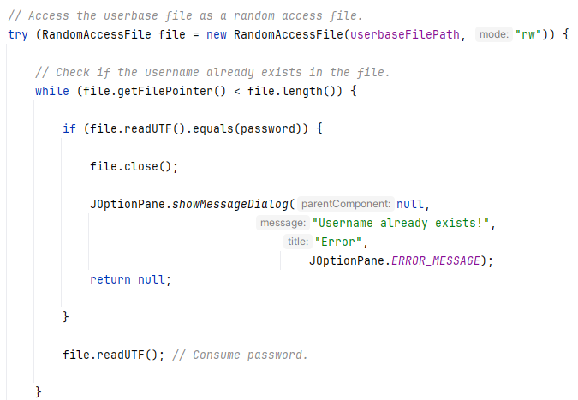

## User

### Creating User File

When a new user creates an account, we create a new CSV file to hold which companies belong to them—named after their username, aimed towards fulfilling criterion 1.

Code 9 Creating User file.

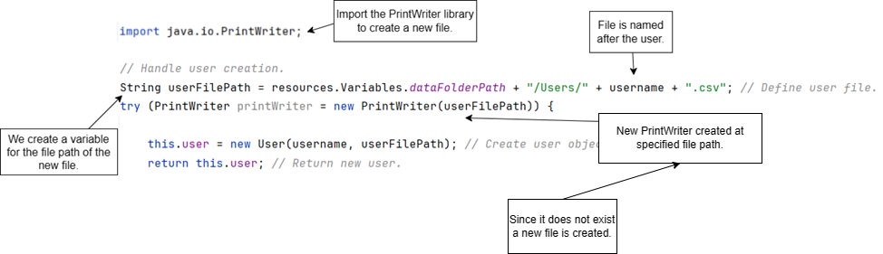

### Retrieving User’s Companies

To be able to generate the dashboard interface with the correct companies belonging to the user showing the program must first load the company files the user has.

Code 10 Retrieving companies for the user.

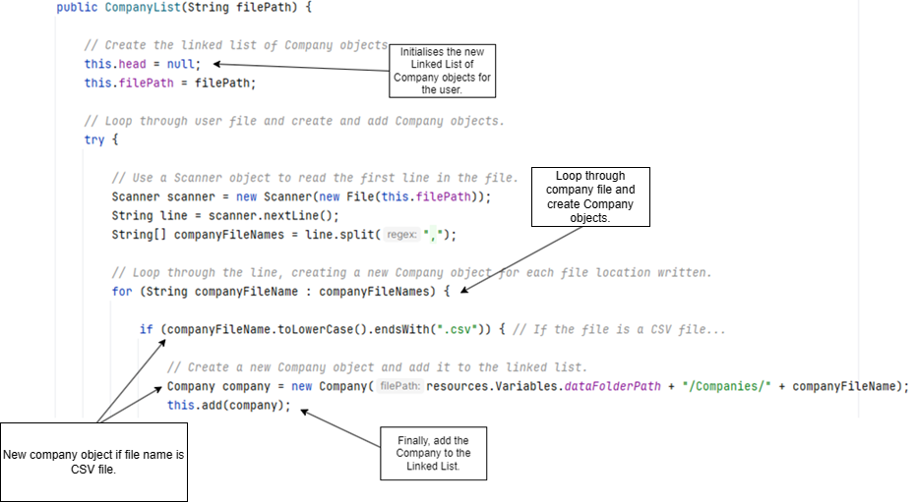

## Company

Each company has their data stored in a CSV file, a text file format that uses commas to separate values[10]. Acting somewhat as a table, this file is useful as it can be opened and modified in programs like Microsoft Excel[11], a program used frequently by the client, hence, why the file format was chosen. This fulfills success criterion 2.

### Structure

The file was broken into two sections using headers, details, and statistics. The details section holds basic information about the company (such as its name, description, and country), while the statistics section holds different revenues and costs as well as the associated data with each.

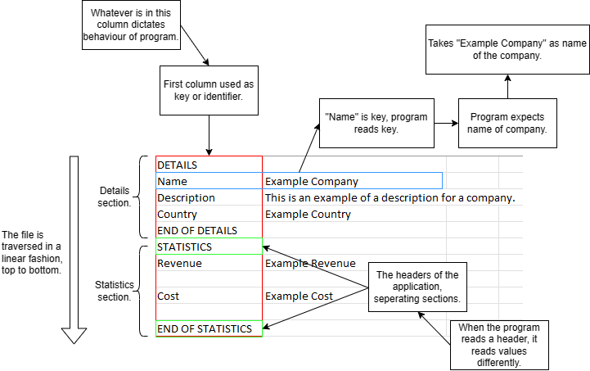

Figure 1 Company CSV file structure.

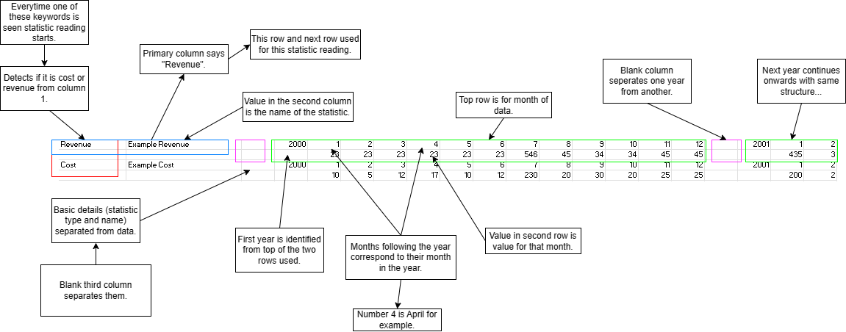

Figure 2 Statistic section and data structure.

### Retrieving Company Data

The use of CSV files for storing dynamic company data leads to complicated file loading and sorting. When checking for the data of a company the program looks for specific headers within the file, such as “DETAILS” and “STATISTICS”.

Code 11 Reading company details method code.

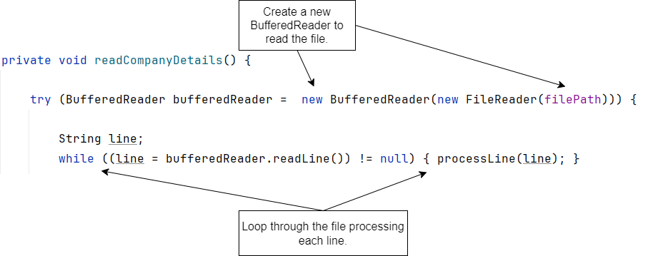

Code 12 Checking for the statistics header code.

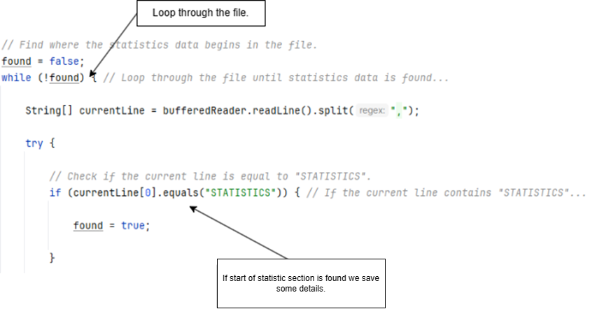

Code 13 Adding statistics from file.

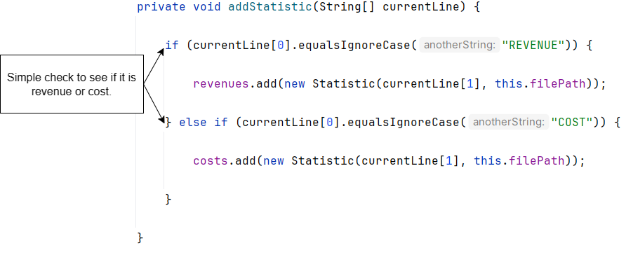

### Retrieving Statistic Data

Code 14 Starting to read Statistic data code.

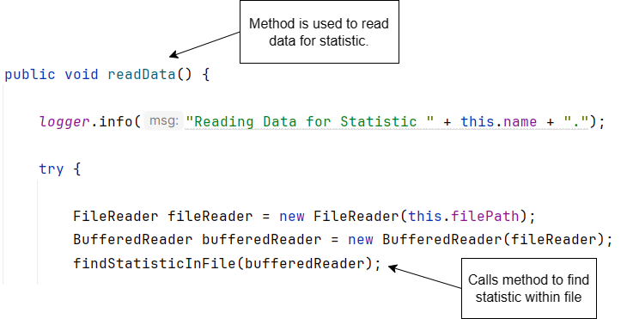

Code 15 Searching for Statistic data code.

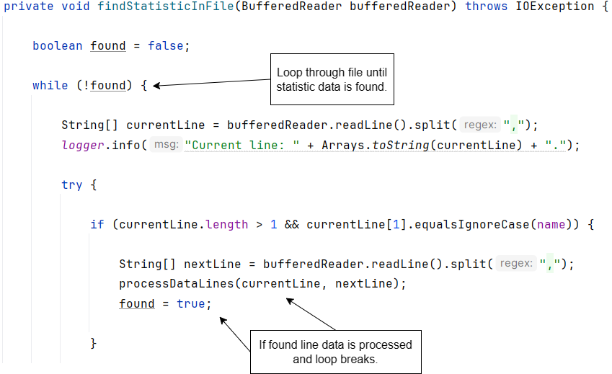

Code 16 Adding Statistic data code.

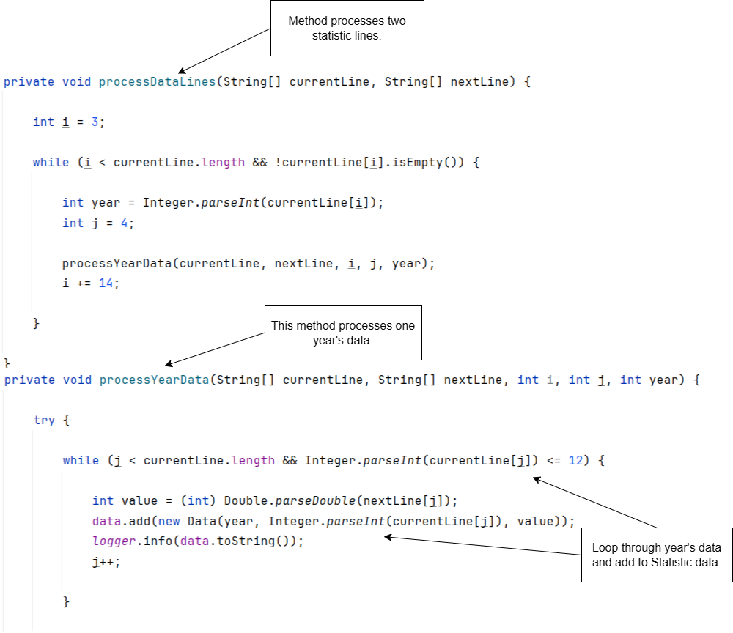

# Functionality

## Company Merging (ArrayList of Objects[12], For Each Loop[13] & Comparator[14])

This feature was implemented to address success criterion 11.

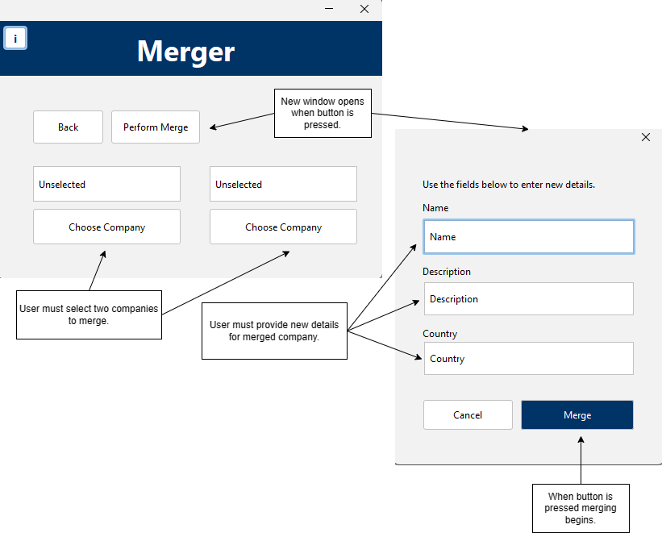

Screenshot 2 Company merging flow.

Code 17 Merge companies method code snippet.

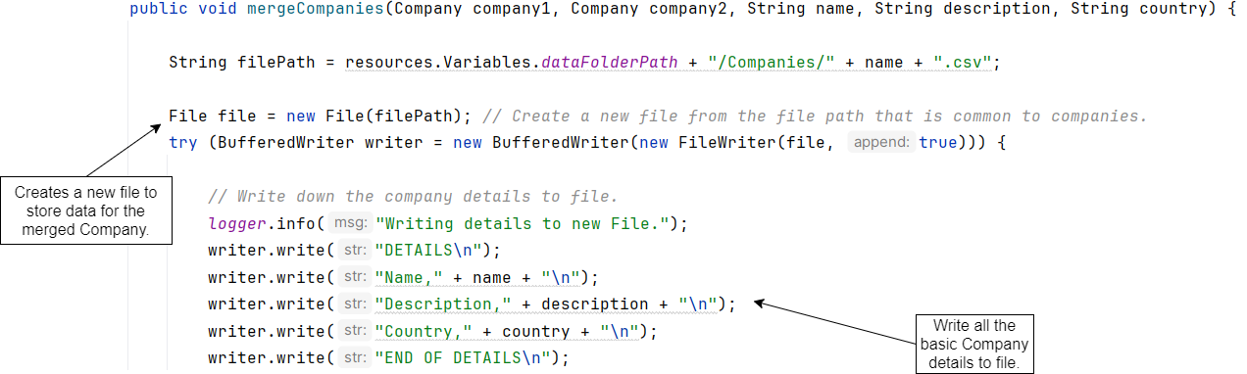

Code 18 Combination of statistics code snippet.

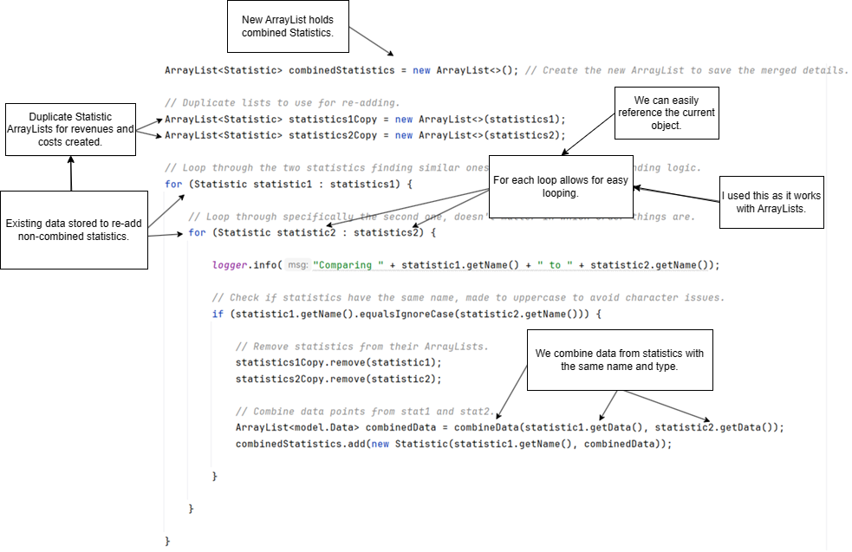

Code 19 Combination of data.

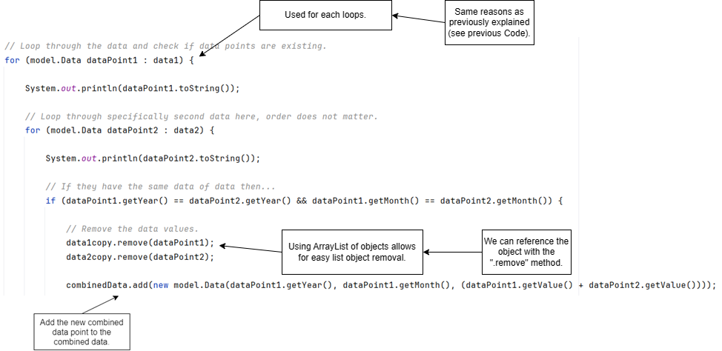

Code 20 Sorting of combined Data objects using a Comparator.

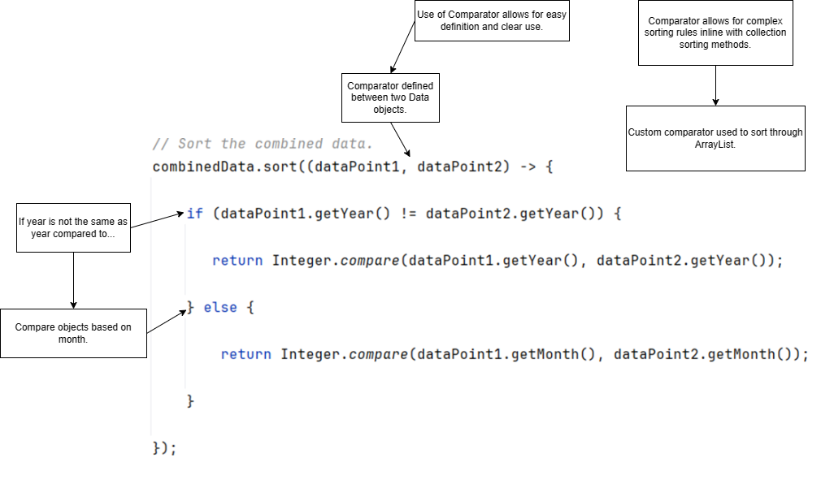

## Company Valuation (ArrayList of Objects, For Each Loop, For Loop[15])

The ability to predict the value of a company was added in response to success criterion 9. This also addresses criterion 10, as the code snippets can be used to predict the value of a company over varying timespans, meaning, that the user can input a different number of years to predict for.

### Data Extrapolation

Code 21 All data extrapolation.

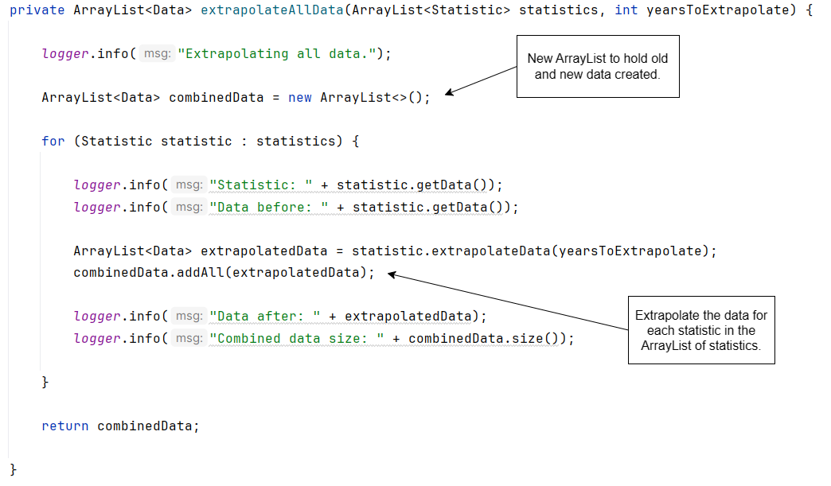

Code 22 Data extrapolation.

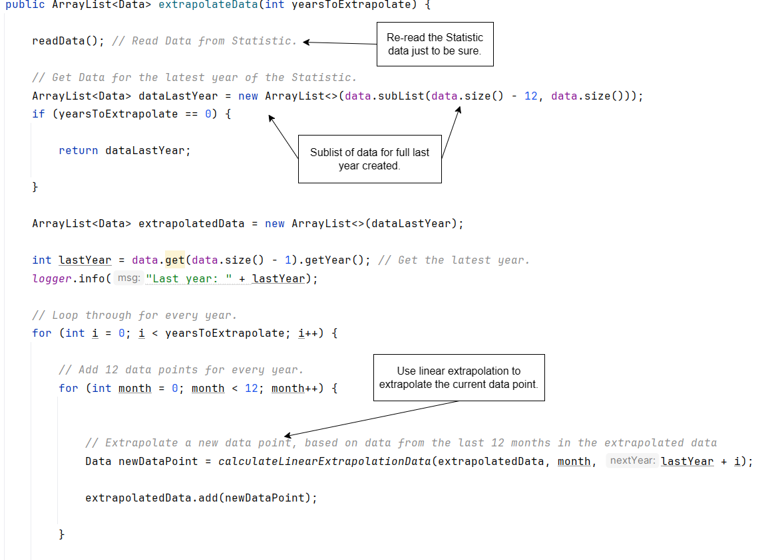

Code 23 Extrapolation of data points using linear regression calculations.

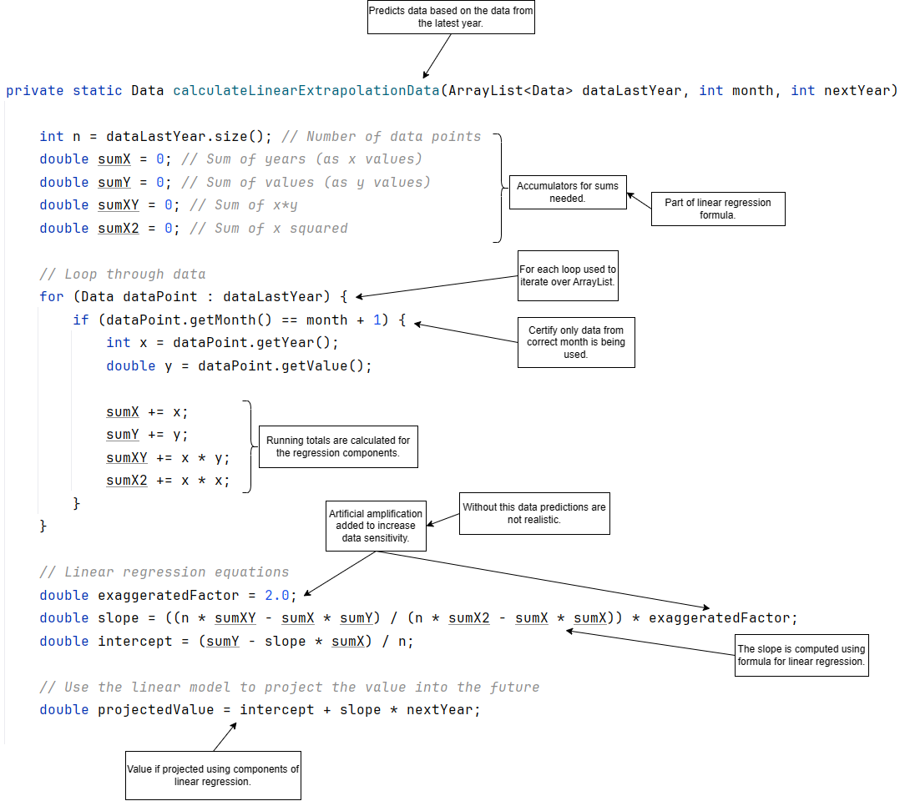

### Final Calculation

Code 24 Final value calculation.

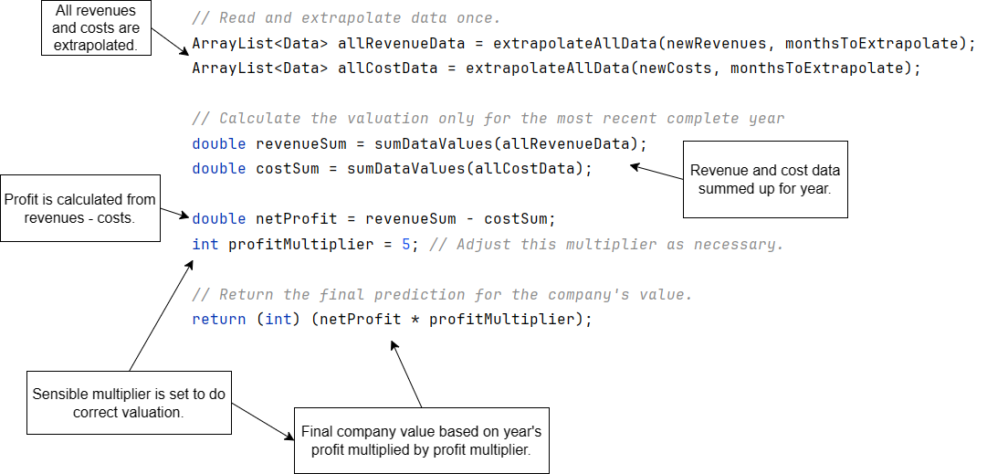

## Statistic Graphing (ArrayList of Objects, For Each Loop)

Statistics are graphed using the JFreeChart library[16]. This feature aims to fulfill success criterion 7.

Code 25 Converting Statistic data to JFreeChart Month.

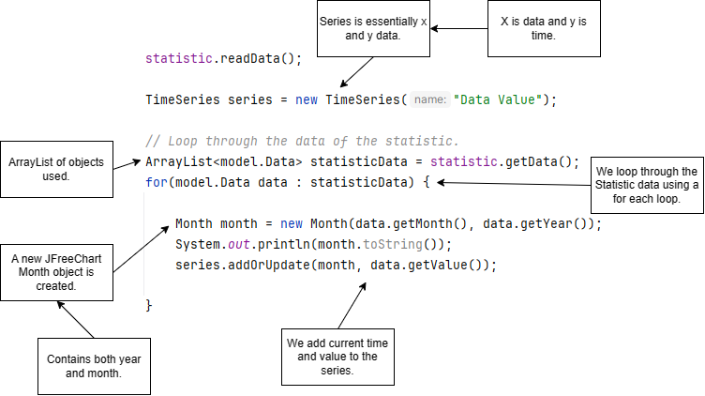

Code 26 Creating JFreeChart.

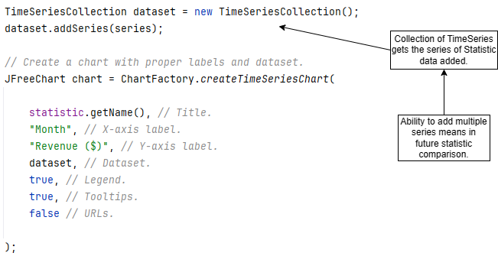

Code 27 Displaying JFreeChart.

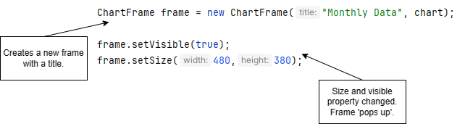

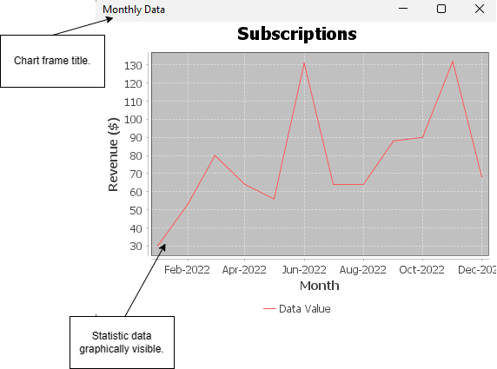

Screenshot 3 JFreeChart graphed statistic.

## Linked List of Company Objects

I decided to structure the program in such a way that the User class aggregates or ‘has’ a CompanyList object. The CompanyList object acts as the LinkedList controller, while each Company object is a node within the LinkedList. To make this work, the CompanyList held by the User object has a root Company object, and each Company object has a reference to the next Company.

My main reason for using a LinkedList instead of a fixed array of objects is because it is a dynamic data structure. This is advantageous because it means that if a user wishes to add more companies or remove companies they can do so, and the data structure does not need to have a fixed or set size limitation. The only downside of this is that this is less memory efficient, however, with modern devices and the expected workload the memory efficiency is not a large concern for the client.

# Interface

Code 28 Setting of interfaces LookAndFeel.

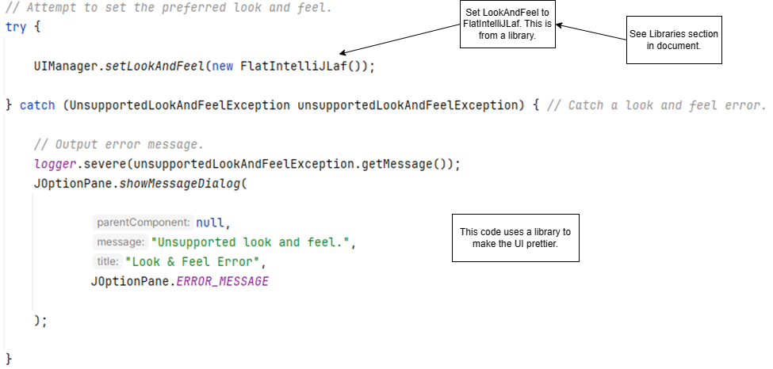

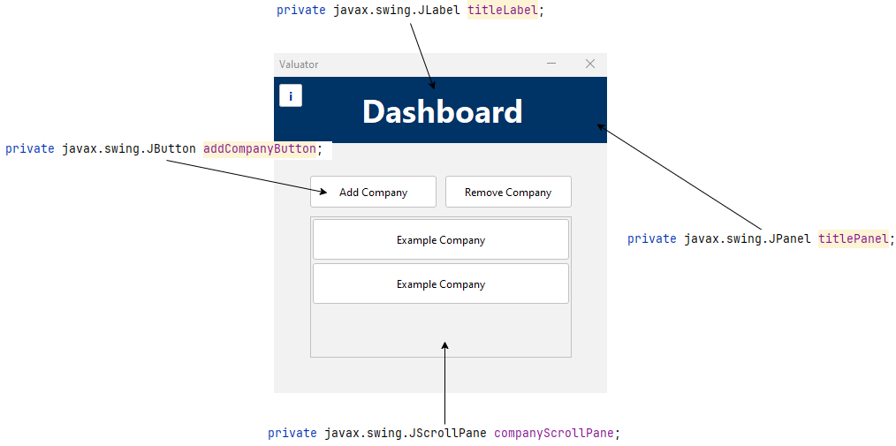

Screenshot 4 Dashboard interface with components annotated.

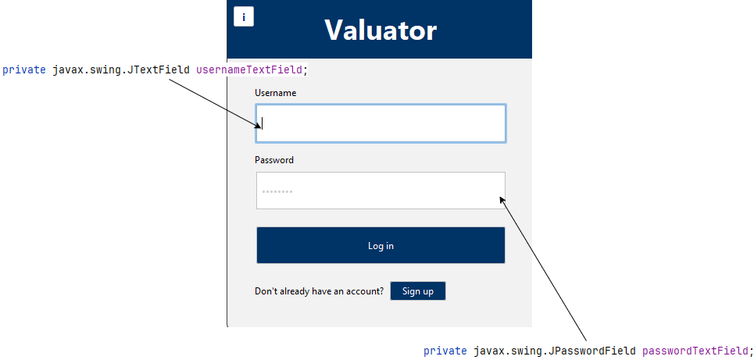

Screenshot 5 Login/signup interface with components annotated.

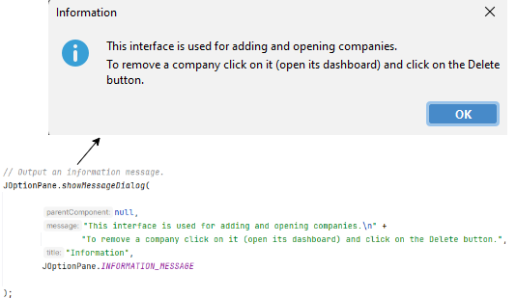

Screenshot 6 Popup with components annotated.

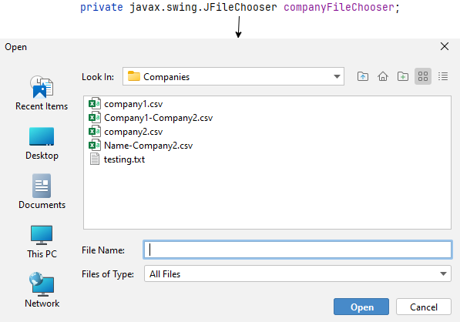

Screenshot 7 File chooser with annotated components.

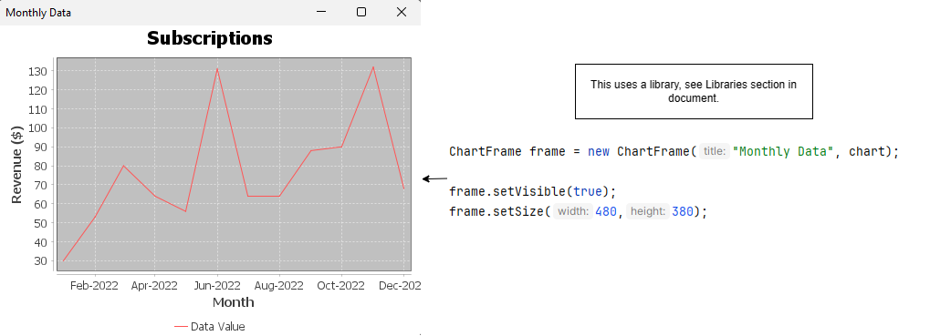

Screenshot 8 Statistic graph with annotated components.

# Libraries

Table 1 Libraries used in the program.

|  |  |  |
| --- | --- | --- |
| **Library** | **Reasons for Use** | **Link** |
| com.formdev.flatlaf.FlatIntelliJLaf | * Used to make interface look more visually appealing. * Makes interface ‘cleaner’. Simply visual changes. | https://www.javadoc.io/static/com.formdev/flatlaf/2.0-rc1/com/formdev/flatlaf/FlatIntelliJLaf.html |
| java.awt.Color | * Used for setting the color of various visual elements. | https://docs.oracle.com/javase/8/docs/api/java/awt/Color.html |
| java.awt.Component | * Used for alignment property. | https://docs.oracle.com/javase/8/docs/api/java/awt/Component.html |
| java.awt.Desktop | * Used to launch a file in an application. | https://docs.oracle.com/javase/8/docs/api/java/awt/Desktop.html |
| java.awt.Dimension | * Width and height of an object in a single component. * Used for sizing buttons. | https://docs.oracle.com/javase/8/docs/api/java/awt/Dimension.html |
| java.awt.event.ActionEvent | * Primarily used for button pressing events. * Can be used to trigger actions. | https://docs.oracle.com/javase/8/docs/api/java/awt/event/ActionEvent.html |
| java.io.* | * General use of different parts of the IO library. * Used for input and output in the application. | https://docs.oracle.com/javase/8/docs/api/java/io/package-summary.html |
| java.io.BufferedWriter | * Used through program to get data from file line by line. * Can easily read CSV file line to array. | https://docs.oracle.com/javase/8/docs/api/java/io/BufferedWriter.html |
| java.io.File | * Used to act as simply a file. * Used for when reading a file. * Can store the read file as a file object. * Used in a program for easy file writing and reading.   + Benefit is path does not need to be re-specified. | https://docs.oracle.com/javase/8/docs/api/java/io/File.html |
| java.io.FileWriter | * Used to write details to files. | https://docs.oracle.com/javase/8/docs/api/java/io/FileWriter.html |
| java.io.IOException | * Exception thrown if there is an issue with input output. * Used during file reading and writing. * In program catches issues and we can output to user. | https://docs.oracle.com/javase/8/docs/api/java/io/IOException.html |
| java.io.PrintWriter | * Also used for writing files in the program. * Can be used to create a new file (used to create user file). | https://docs.oracle.com/javase/8/docs/api/java/io/PrintWriter.html |
| java.io.RandomAccessFile | * DAT file reading. * Used for userbase (username and password storage). | https://docs.oracle.com/javase/8/docs/api/java/io/RandomAccessFile.html |
| java.util.ArrayList | * Used by program to store list without specified size. * Also stores in order. | https://docs.oracle.com/javase/8/docs/api/java/util/ArrayList.html |
| java.util.Arrays | * Used primarily for methods such as converting to String. * Used in program for logging. | https://docs.oracle.com/javase/8/docs/api/java/util/Arrays.html |
| java.util.Collections | * Used for its method to find max value from ArrayList.   + Max value of complete years for prediction. | https://docs.oracle.com/javase/8/docs/api/java/util/Collections.html |
| java.util.logging.Logger | * Used in the program to log details. | https://docs.oracle.com/javase/8/docs/api/java/util/logging/Logger.html |
| java.util.NoSuchElementException | * Thrown by program when an element does not exist.   + If a company does not exist. | https://docs.oracle.com/javase/8/docs/api/java/util/NoSuchElementException.html |
| java.util.Scanner | * Used to read through first file of user file with ease. | https://docs.oracle.com/javase/8/docs/api/java/util/Scanner.html |
| javax.swing.* | * Lightweight interface components that work on multiple platforms. * Used by program for visual interface. | https://docs.oracle.com/javase%2F7%2Fdocs%2Fapi%2F%2F/javax/swing/package-summary.html |
| javax.swing.Box |  | https://docs.oracle.com/javase/8/docs/api/javax/swing/Box.html |
| javax.swing.BoxLayout | * A layout used on every interface. | <https://docs>.oracle.com/javase%2F8%2Fdocs%2Fapi%2F%2F/javax/swing/BoxLayout.html |
| javax.swing.Jbutton | * A simple button. * Used numerous times in program. | <https://docs>.oracle.com/javase/8/docs/api/javax/swing/Jbutton.html |
| javax.swing.JfileChooser | * Used when selecting company files. | https://docs.oracle.com/javase/8/docs/api/javax/swing/JFileChooser.html |
| javax.swing.JOptionPane | * Used for popups in the program. | https://docs.oracle.com/javase%2F8%2Fdocs%2Fapi%2F%2F/javax/swing/JOptionPane.html |
| javax.swing.JPanel | * Used for panels holding elements. | https://docs.oracle.com/javase/8/docs/api/javax/swing/JPanel.html |
| javax.swing.JScrollPane | * Used for elements such as:   + Statistics buttons   + Company buttons * Allows for dynamic adding of elements without compromising page size. | https://docs.oracle.com/javase/8/docs/api/javax/swing/JScrollPane.html |
| javax.swing.UIManager | * Used to manage the LookAndFeel of the program. | https://docs.oracle.com/javase/8/docs/api/javax/swing/UIManager.html |
| javax.swing.UnsupportedLookAndFeelException | * Used if the library for LookAndFeel is loaded improperly. * Allows the program to still run without the desired LookAndFeel. | https://docs.oracle.com/javase%2F7%2Fdocs%2Fapi%2F%2F/javax/swing/UnsupportedLookAndFeelException.html |
| org.jfree.chart.ChartFactory | * Used for chart creation.   + Statistics charts | https://www.jfree.org/jfreechart/api/javadoc/org/jfree/chart/ChartFactory.html |
| org.jfree.chart.ChartFrame | * Creating frame holding the chart. | https://www.jfree.org/jfreechart/api/javadoc/org/jfree/chart/ChartFrame.html |
| org.jfree.chart.JFreeChart | * Main object for a new chart. | https://www.jfree.org/jfreechart/api/javadoc/org/jfree/chart/JFreeChart.html |
| org.jfree.data.time.Month | * Month of data point for a statistic. | https://www.jfree.org/jfreechart/api/javadoc/org/jfree/data/time/Month.html |
| org.jfree.data.time.TimeSeries | * X-axis of a graph which uses time. | https://www.jfree.org/jfreechart/api/javadoc/org/jfree/data/time/TimeSeries.html |
| org.jfree.data.time.TimeSeriesCollection | * Holds a collection of data. * Is placed onto a TimeSeries. * Used when adding chronological statistic data to graph. | https://www.jfree.org/jfreechart/api/javadoc/org/jfree/data/time/TimeSeriesCollection.html |

# References

*Aggregation in Java*. (n.d.). Retrieved from Javatpoint: https://www.javatpoint.com/aggregation-in-java

*Comma Separated Values (CSV) Standard File Format*. (n.d.). Retrieved 2 27, 2024, from Edoceo, Inc: http://edoceo.com/utilitas/csv-file-format

Debnath, M. (2021, March 25). *Random File Access Using Java*. Retrieved from Developer.com: https://www.developer.com/database/random-file-access-using-java/

GeeksforGeeks. (2023, February 16). *For-each loop in Java*. Retrieved from GeeksforGeeks: https://www.geeksforgeeks.org/for-each-loop-in-java/

Gillis, A. S. (n.d.). *TechTarget*. (S. Lewis, Editor) Retrieved from What is object-oriented programming?: https://www.techtarget.com/searchapparchitecture/definition/object-oriented-programming-OOP

*Java Exceptions - Try...Catch*. (n.d.). Retrieved from W3schools: https://www.w3schools.com/java/java_try_catch.asp

*Java Method Overloading*. (n.d.). Retrieved from W3schools: https://www.w3schools.com/java/java_methods_overloading.asp

Lawrence University. (n.d.). *Working with ArrayLists*. Retrieved from Lawrence: https://www2.lawrence.edu/fast/GREGGJ/CMSC150/062ArrayLists/ArrayLists.html#:~:text=What%20is%20an%20ArrayList%3F,a%20size%20for%20the%20array.

Liang, Y. D. (2017). Object Oriented Thinking. In Y. D. Liang, *Introduction to Java Programming, Brief Version, Eleventh Edition, Global Edition* (pp. 390-407). Pearson.

Microsoft. (n.d.). *Free online spreadsheet software: Excel: Microsoft 365*. Retrieved from Free Online Spreadsheet Software: Excel | Microsoft 365: https://www.microsoft.com/en-us/microsoft-365/excel

Oracle. (2024, January 8). *Comparator (java platform SE 8 )*. Retrieved from Oracle: https://docs.oracle.com/javase/8/docs/api/java/util/Comparator.html

Oracle. (2024, January 8). *RandomAccessFile (Java Platform SE 8)*. Retrieved from Oracle: https://docs.oracle.com/javase/8/docs/api/java/io/RandomAccessFile.html

S, R. A. (2023, October 11R). *What is Encapsulation in Java and How to Implement It*. Retrieved from simplilearn: https://www.simplilearn.com/tutorials/java-tutorial/java-encapsulation#:~:text=Encapsulation%20in%20Java%20is%20the,the%20class%20can%20access%20them.

Simplilearn. (2022, December 22). *Understanding for loop in java with examples and syntax*. Retrieved from Simplilearn: https://www.simplilearn.com/tutorials/java-tutorial/for-loop-in-java#:~:text=For%20loop%20in%20Java%20iterates,the%20condition%20is%20not%20met.

*Working with CSV files*. (n.d.). Retrieved from Fund Recs: https://www.fundrecs.com/blog/working-with-csv-files#:~:text=CSV%20(Comma%20Separated%20Values)%20format,it%20in%20slightly%20different%20ways.

1. (Gillis, n.d.)
2. (Liang, 2017)
3. (S, 2023)
4. (Aggregation in Java, n.d.)
5. (Java Method Overloading, n.d.)
6. (Java Exceptions - Try...Catch, n.d.)
7. (Comma Separated Values (CSV) Standard File Format, n.d.)
8. (Oracle, 2024)
9. (Debnath, 2021)
10. (Working with CSV files, n.d.)
11. (Microsoft, n.d.)
12. (Lawrence University, n.d.)
13. (GeeksforGeeks, 2023)
14. (Oracle, 2024)
15. (Simplilearn, 2022)
16. See Libraries section of document.